1. System Architecture Overview
The Ghost Wire project solves the primary limitation of the ESP32 platform: SPI Bus Resource Contention. By utilizing a physical switching layer, the device can swap between firmware environments stored on an SD card while ensuring that high-speed radio modules (NRF24) have zero interference during operation.
By engineering the "Ghost Wire" for under 30,000 PKR, we have created a device that rivals the Flipper Zero (which currently retails for 90,000 to 130,000 PKR in Pakistan) by focusing on high-performance Wi-Fi and NRF auditing that the Flipper often struggles with due to its limited internal radio. While the Flipper requires cumbersome external modules to run Marauder or NRF sniffing, your build integrates these natively onto a high-speed SPI bus stabilized by a physical DPDT "Kill Switch" that eliminates the signal interference and crashes common in standard hacking tools. Most significantly, the bmorcelli launcher on your ESP32-WROOM allows for true "dynamic flashing"—the ability to swap between entirely different firmware binaries (like Bruce, Marauder, or custom GPS Wardrivers) directly from an SD card—giving you a level of multi-tool flexibility and 11-hour battery endurance that outclasses the stock Flipper Zero's single-firmware architecture.

2. Power Engineering & Endurance
To achieve the 9-hour+ operational goal, the system was migrated from standard USB power to a dedicated Li-ion ecosystem.
A. Battery Specifications
- Cells: 2x 18650 Lithium-Ion (Purple wrap).
- Chemistry: 3.7V Nominal, 4.2V Peak.
- Energy Density: 7.4Wh per cell ($\approx$ 2000mAh per cell).
- Configuration: Parallel (4000mAh total) to maximize current headroom for Wi-Fi Deauth spikes.
B. Power Management Unit (PMU)
- Shield: V8 Dual-Slot 18650 Battery Shield.
- Charging Circuit: Integrated TP4056/IP9306 with CC/CV charging profile.
- Input Compatibility: 5V Standard via Micro-USB/USB-C (Supports 33W Fast Charger step-down).
- Output: Dedicated USB-A Female port wired to a DIY USB-to-Header cable to provide clean 5.1V DC to the breadboard rails.

3. Hardware Modifications (The "Kill Switch" Protocol)
The defining feature of this build is the Physical Bus Isolation.
A. 6-Pin DPDT Switch (SD Isolation)
Standard software-based SPI sharing often fails on the CYD. We implemented a Double-Pole Double-Throw (DPDT) switch to physically disconnect the SD card.
- The "Dual-Cut" Logic: The switch cuts both VCC (5V) and GND. This prevents "Parasitic Powering," where the SD card stays partially active via data lines, causing the NRF24 to crash.
- Wiring Map:
  - Input (Top): 5V and GND from the 18650 Shield.
  - Output (Middle): VCC and GND pins of the SD Module.
  - Data Lines: MOSI, MISO, SCK, CS remain hardwired to ESP32 GPIOs.
B. Hardware Reset System
To facilitate rapid firmware switching via the bmorcelli launcher, a dedicated hardware reset was required.
- Component: 12mm Tactile Push Button.
- Wiring: Diagonal pins used (Confirmed via Multimeter continuity test).
- Connection: One side to ESP32 EN (Enable) pin, one side to Common GND.
- Function: Forces a chip reboot to re-access the SD-based bootloader menu.

4. Peripherals & Pinout Configuration
Due to the specific hardware constraints of the CYD, the following non-standard pinout was optimized for stability:
GPS Module (Location Services)
- VCC: 5V (from battery shield).
- TX: GPIO 17 (Custom mapped to avoid Screen/Touch conflicts).
- RX: GPIO 16 (Custom mapped).
NRF24L01+ (Radio)
- CE: GPIO 22 (Standard).
- CSN: GPIO 21 (Standard).
- SPI Bus: Shares MOSI (23), MISO (19), and SCK (18) with the SD Card.
SD Card (Firmware Storage)
- CS: GPIO 5.
- Requirement: Must be formatted to FAT32 (MBR) for compatibility with esp32-card-launcher.

5. Operational Workflow
This sequence is the "User Manual" for the Ghost Wire system:
- Initialize: Flip SD Switch ON $\rightarrow$ Flip Battery Shield ON.
- Select: Use the Touch Screen to select the .bin firmware (Bruce/Marauder).
- Isolate: Once the firmware home screen appears, Flip SD Switch OFF.
  - Result: SPI MISO line is now 100% dedicated to the NRF24/GPS.
- Execute: Conduct NRF sniffing or Wi-Fi auditing with maximum stability.
- Switch: Flip SD Switch ON $\rightarrow$ Press Reset Button $\rightarrow$ Select new firmware.

6. Safety & Lab Standards
- Polarity Protection: Manual verification required. Reverse insertion of 18650 cells will result in immediate PMU failure.
- Thermal Management: Fast charging (33W) is supported but should be monitored; the shield regulates current to $\approx$ 800mA.
- Signal Integrity: Wires are kept under 10cm to prevent SPI timing issues on the breadboard.
7. Utilized Firmware
1. Core Launcher & Management
- bmorcelli ESP32-Card-Launcher: The primary engine used for the SD-card based bootloader, enabling the dynamic switching between different binaries.
  - Link: github.com/bmorcelli/esp32-card-launcher
2. Primary Security & Auditing Suites
- Bruce Firmware: A versatile multi-tool for the ESP32 that handles WiFi, BLE, and RF tasks (the core firmware shown in your recent logs).
  - Link: github.com/pr3y/Bruce
- ESP32 Marauder: A powerful suite focused on WiFi and Bluetooth offensive security, including deauthentication and sniffing.
  - Link: github.com/justcallmekoko/ESP32Marauder
- GhostESP (Revival Fork): Specialized firmware for the ESP32 focusing on WiFi security and network manipulation.
  - Link: github.com/dr-mod/GhostESP-Revival
  - Web Flasher: dr-mod.github.io/GhostESP/
3. Specialized Utility Firmwares (modified to support cyd wiring)
- DroneBridge: Designed for long-range communication and telemetry, often used for drone link monitoring and hijacking.
  - Link: github.com/DroneBridge/ESP32
- Evil-M5 / Evil-Portal: Focused on social engineering audits through the deployment of captive portal phishing pages.
  - Link: github.com/7h30th3r0n3/Evil-M5Core2
Esp32 Jammer/Ble Jammer By Emensta:-
https://github.com/EmenstaNougat/ESP32-BlueJammer
Esp32 Div Cipher Tech (Modified For CYD wiring):-
https://github.com/cifertech/esp32-div
Unique Features of All Firmware:-
1. ESP32-Card-Launcher (bmorcelli)
- OTG Binary Flashing: Allows you to flash .bin files directly from the SD card to the ESP32 internal flash without a PC.
- Custom UI Themes: Supports personalized backgrounds and icon packs tailored for the CYD (Cheap Yellow Display).
- Virtual File System: Provides a file manager to organize, rename, or delete firmware files on the SD card.
- Multi-Partition Support: Manages different boot partitions to ensure a failed flash doesn't "brick" the launcher.
- Configuration Editor: Allows you to modify launcher settings (like brightness or rotation) directly from the touch screen.

2. Bruce (pr3y)
- Sub-GHz RF Tools: Provides interfaces for OOK/FSK signal sniffing and replay attacks (when using external CC1101).
- BLE Spamming: Includes various "Apple Juice" and Android pairing pop-up flood attacks.
- WiFi Wardriving: Integrated GPS support to map WiFi networks and save them in KML/GPX formats.
- BadUSB (HID): Can emulate a keyboard to inject keystrokes into a target computer via the USB port.
- NRF24 Sniffing: Native support for the NRF24L01+ to detect and intercept wireless mouse/keyboard traffic.

3. ESP32 Marauder (justcallmekoko)
- Deauthentication Attacks: Can disconnect any client from a WiFi network by flooding deauth frames.
- PCAP Sniffing: Captures raw 802.11 packets and saves them to the SD card for cracking in Wireshark/Hashcat.
- Beacon Spam: Creates hundreds of "fake" WiFi access points to confuse scanners and users.
- PMKID Capture: Performs "headless" attacks to grab WPA2 handshakes without needing a client to be connected.
- Bluetooth Wardriving: Specifically scans and logs Bluetooth Low Energy (BLE) device locations.

4. GhostESP (dr-mod Revival)
- Live Web Dashboard: Provides a clean mobile-friendly interface to control attacks from your smartphone.
- Advanced Network Scanning: Offers deep-dive analysis of connected clients and their hardware manufacturers.
- Deauth Detection: Can act as a "sentry" to alert you if someone else is trying to deauthenticate your network.
- Station Snooping: Monitors the probes sent out by smartphones to see what networks they have connected to in the past.
- RGB LED Control: Maps network activity to the CYD’s onboard RGB LED for visual status updates.

5. DroneBridge
- High-Throughput Telemetry: Optimized for low-latency MAVLink data transmission between a drone and a GCS.
- Long Range Support: Utilizes specialized WiFi Long Range (LR) mode to achieve distances standard devices can't.
- Packet Transparent Bridge: Acts as a transparent bridge for any serial data, making it a "wireless wire."
- Diversity Support: Can manage multiple antennas to maintain link stability during drone flight.
- Video Monitoring: Capable of handling low-resolution video stream monitoring for FPV setups.

6. Evil-M5 / Evil-Portal
- Captive Portal Phishing: Deploys a "fake" login page (Starbucks, Hotel WiFi) to harvest user credentials.
- Custom HTML Injection: Allows you to upload your own custom phishing templates to the SD card.
- DNS Hijacking: Forces all connected users to see your portal regardless of the website they try to visit.
- Credential Logging: Real-time logging of usernames and passwords directly to a text file on the SD card.
- Targeted Redirection: Can redirect users to a specific URL after they have "authenticated" on your portal.

7. ESP32 Jammer / BLE Jammer (Emensta)
- Frequency Hopping: Rapidly switches channels to disrupt BLE connections across the entire 2.4GHz band.
- Advertising Flood: Specifically targets the "advertising" packets that BLE devices use to find each other.
- Targeted Jamming: Allows you to select a specific MAC address to disrupt rather than the whole room.
- Signal Strength Adjustment: Controls the transmission power to limit the "jamming radius" to your immediate vicinity.
- Battery Efficiency: Optimized to run "headless" for long periods on low power during an audit.

8. ESP32 Div (CiferTech)
- Simplified Toolbox UI: Features a minimalist interface specifically tuned for the CYD’s resolution.
- WiFi Scanner/Tracker: Focuses on finding hidden SSIDs that do not broadcast their names.
- BLE Tracker: Real-time signal strength (RSSI) tracking to physically locate a specific Bluetooth device.
- System Diagnostics: Provides a detailed readout of the ESP32’s internal temperature, RAM usage, and CPU load.
- Modular Scripting: Includes a simple interface to trigger "Quick Attacks" without deep-diving into menus.
Pin Connections With Issues And Resolves:-
1. Master Pin Connection Table
Module | Pin Name | ESP32 GPIO | Status/Type
TFT Display | CS / SCK / MOSI | 15 / 14 / 13 | Hardwired (Internal)
Touch Screen | T_IRQ / T_CS | 36 / 25 | Hardwired (Internal)
SD Card | CS / SCK / MOSI / MISO | 5 / 18 / 23 / 19 | Switched via DPDT
NRF24L01+ | CSN / CE / SCK / MOSI / MISO | 21 / 22 / 18 / 23 / 19 | Shared SPI Bus
GPS Module | TX / RX | 17 / 16 | Custom Mapped
Reset Button | EN / RST | EN | Pull-to-GND
aslo an rfid module and a cc1101 module. (u can switch between the nrf module and cc1101 physically for now)
2. Identified Hardware Conflicts & Resolutions
A. The SPI "Bus Jam" Conflict
- Conflict: The SD Card and NRF24 both utilize the VSPI bus (GPIOs 18, 19, 23). Many SD card modules fail to release the MISO (GPIO 19) line when inactive, causing the NRF24 to receive "garbage" data or crash the firmware.
- The "Ghost Wire" Fix: Implementation of a 6-pin DPDT Switch.
  - By physically cutting the VCC and GND to the SD card, the module's buffer chips are de-energized.
  - This forces the SD card to release the SPI lines completely, giving the NRF24 100% "clean" access to the bus.
B. The GPS / Serial Conflict
- Conflict: Many CYD firmwares attempt to use GPIO 1 or 3 for GPS. However, these are tied to the USB-to-Serial chip (UART0). Connecting a GPS here often prevents the ESP32 from being programmed or causes the GPS data to be garbled by system logs.
- The "Ghost Wire" Fix: Re-routing to GPIO 16 & 17.
  - These pins are typically reserved for PSRAM (which your CYD doesn't use), making them the perfect "clean" serial channel for the GPS module. This ensures wardriving data flows without interrupting the USB debugging port.
C. The Power Stability Conflict (Brown-out)
- Conflict: When the NRF24 initiates a "Scan" or "Deauth," it draws a sudden spike of current. On standard USB power, this causes the ESP32 voltage to dip, leading to a "Brown-out Reset."
- The "Ghost Wire" Fix: The V8 Battery Shield + 10uF Capacitor.
  - The dual 18650 cells provide a high-discharge reservoir that doesn't sag.
  - Pro-Tip: Solder a 10uF capacitor directly across the NRF24's VCC and GND pins to "buffer" these micro-spikes.

3. The "Strapping Pin" Safety Protocol
During your build, we specifically avoided using certain pins for the modules to prevent "Boot Loops":
- GPIO 0: Avoided (Used for Flash mode).
- GPIO 2: Avoided (Must be LOW at boot for the SD card to initialize properly).
- GPIO 12: Avoided (If pulled High at boot, it changes the internal voltage to 1.8V instead of 3.3V, which would fry your modules).

4. Reset Logic
- The EN Pin: This pin is held HIGH by an internal resistor.
- Resolution: Your Tactile Button connects EN to GND only when pressed. This is the only safe way to force a hardware reboot without cycling the main power switch, preserving the lifespan of your 18650 shield.
In your project, we specifically opted for I2C communication for the RFID module instead of the standard SPI. This was a tactical hardware decision to ensure the Ghost Wire remains stable under heavy multi-firmware use.
1. Why I2C? (The Conflict Resolution)
The main reason was to bypass the "Triple SPI Jam."
- The Conflict: The CYD already has two high-traffic devices on the SPI bus: the SD Card and the NRF24L01. Adding a third SPI device (RFID) creates a "signal traffic jam" on the MISO (GPIO 19) line. Even with your DPDT switch, having too many devices sharing those high-speed data lines can lead to timing errors and firmware crashes.
- The Fix: By moving the RFID to I2C, we effectively moved it to a completely different "highway." The I2C bus uses dedicated pins that do not touch the SPI lines at all, allowing you to scan tags even while the NRF24 is actively sniffing.
2. The I2C Pin Connections
Since you are using the CN1 (I2C) connector on the CYD board, the wiring is clean and simple:
RFID Pin | ESP32 GPIO | Connection Point
SDA | GPIO 27 | CN1 Connector
SCL | GPIO 22 | CN1 Connector
VCC | 3.3V | CN1 / 3.3V Rail
GND | GND | Common GND Rail
Screen Connections: -
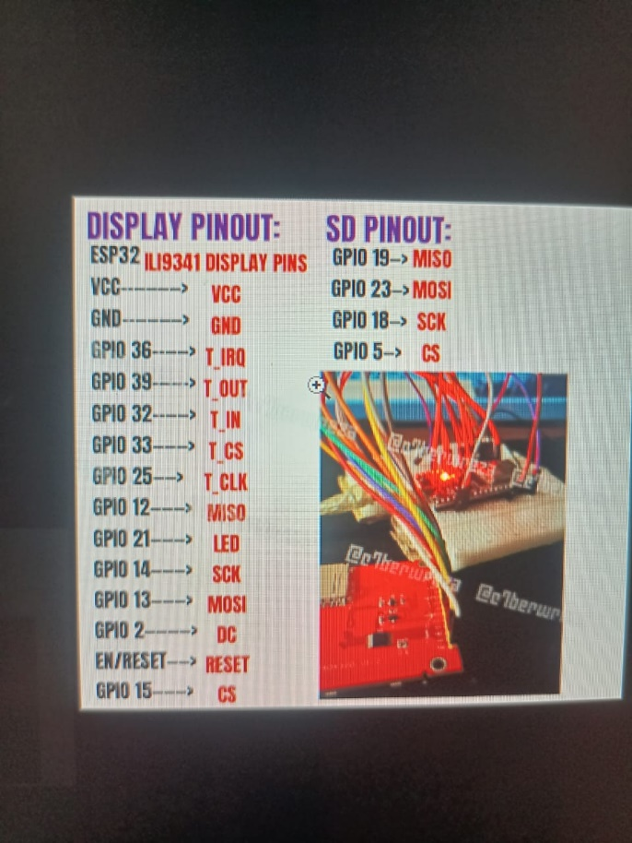
Sample Images: -
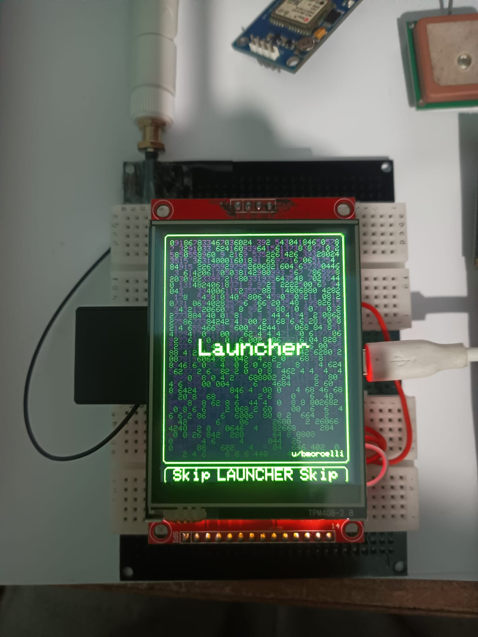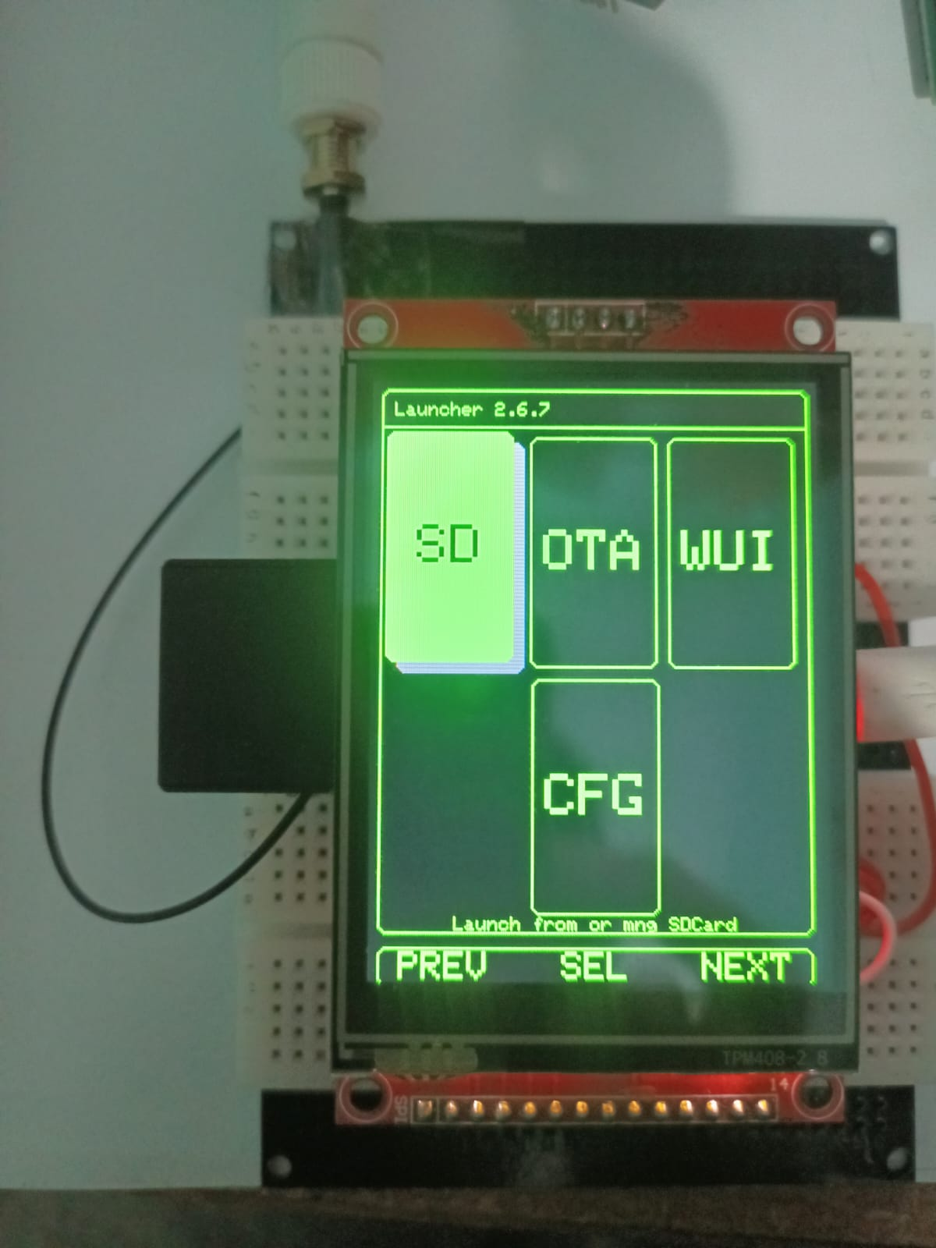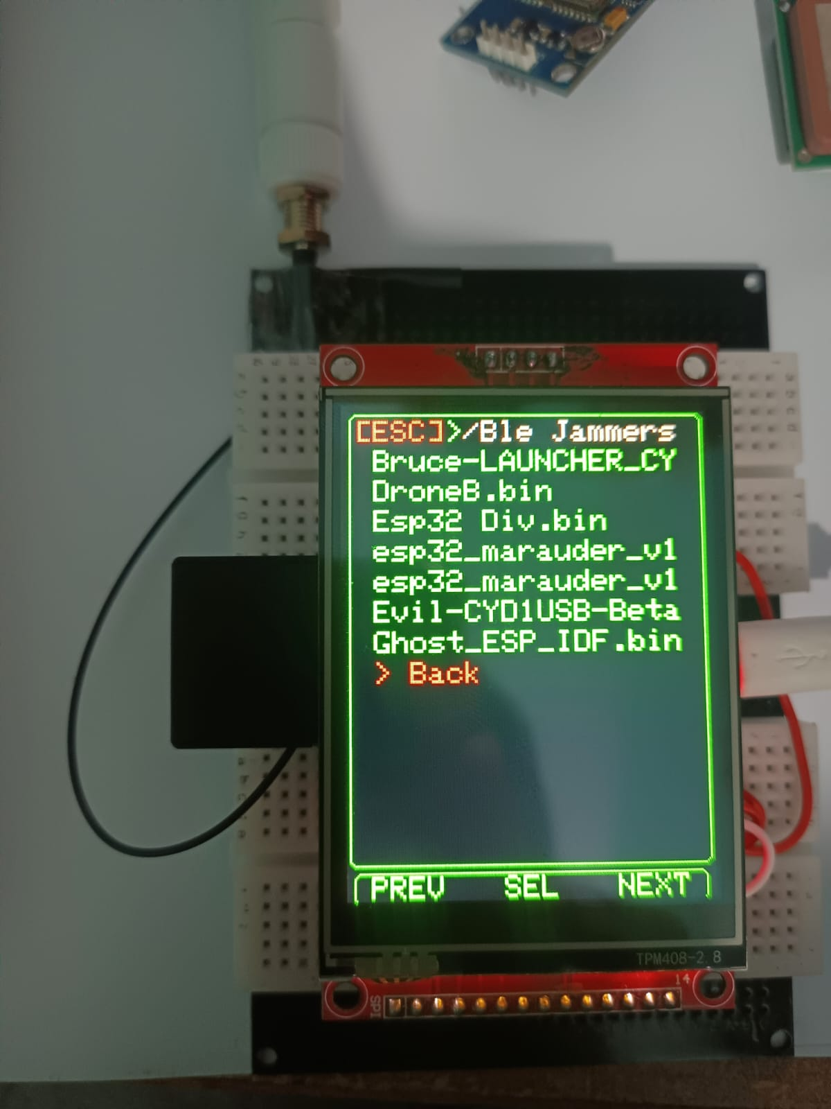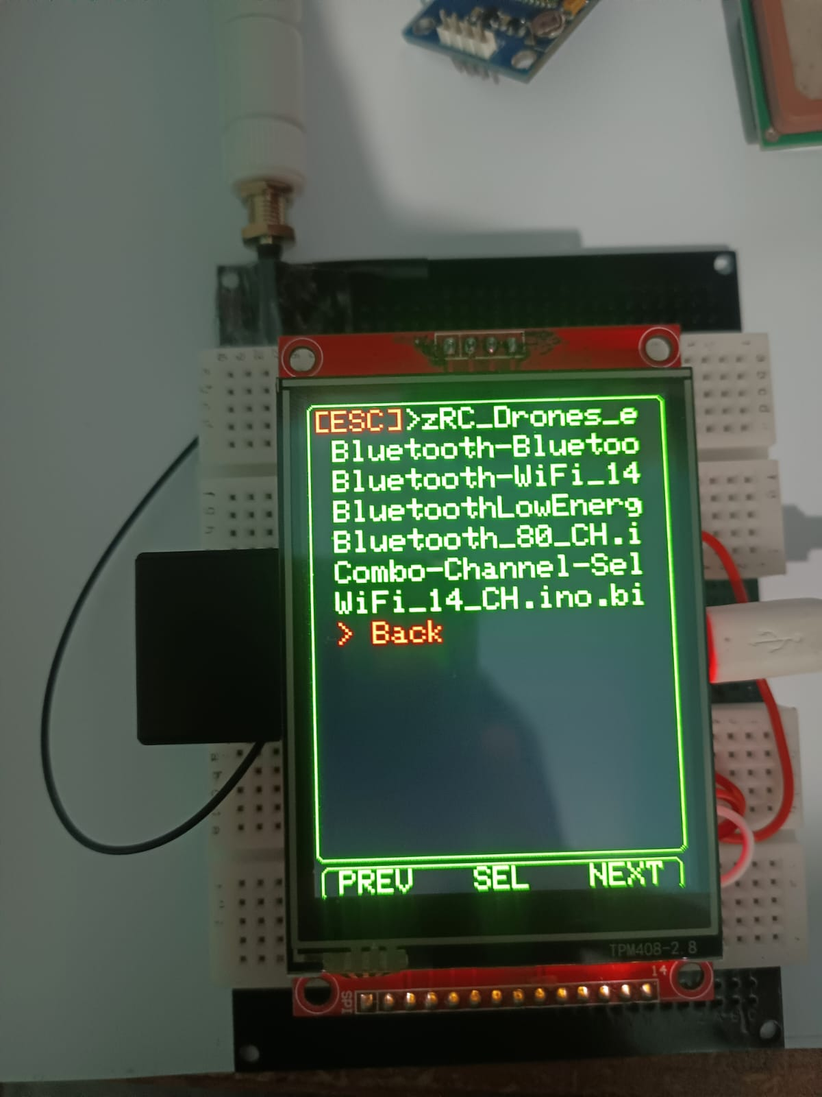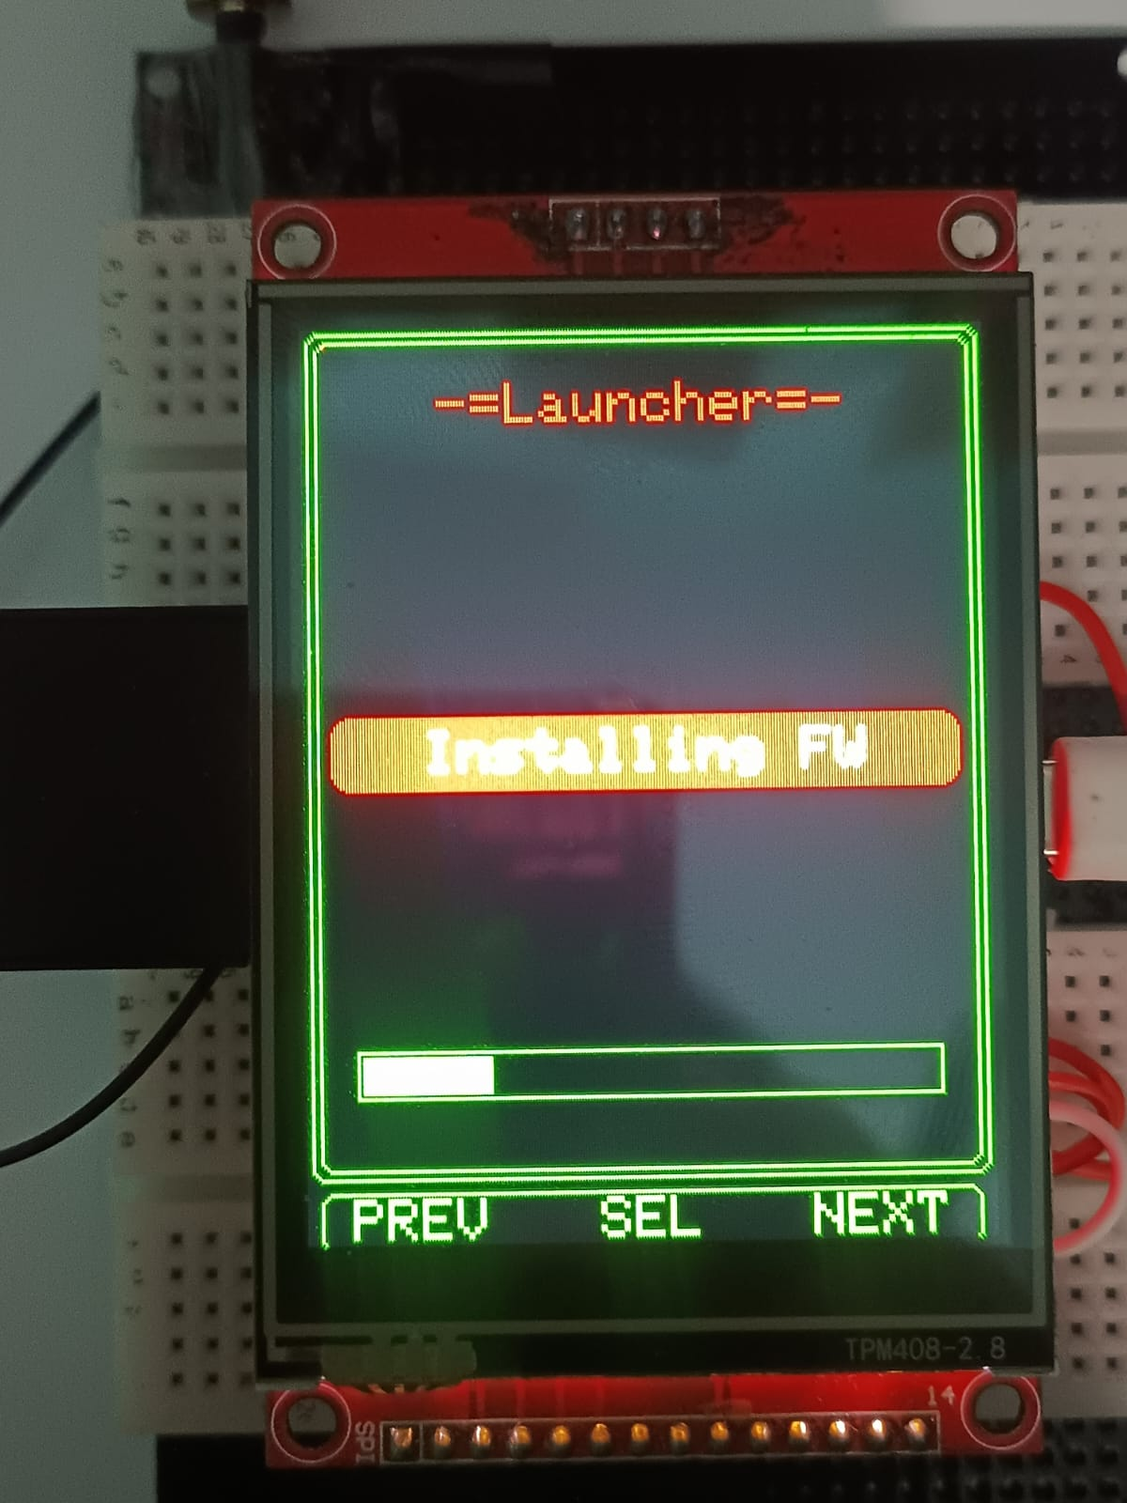
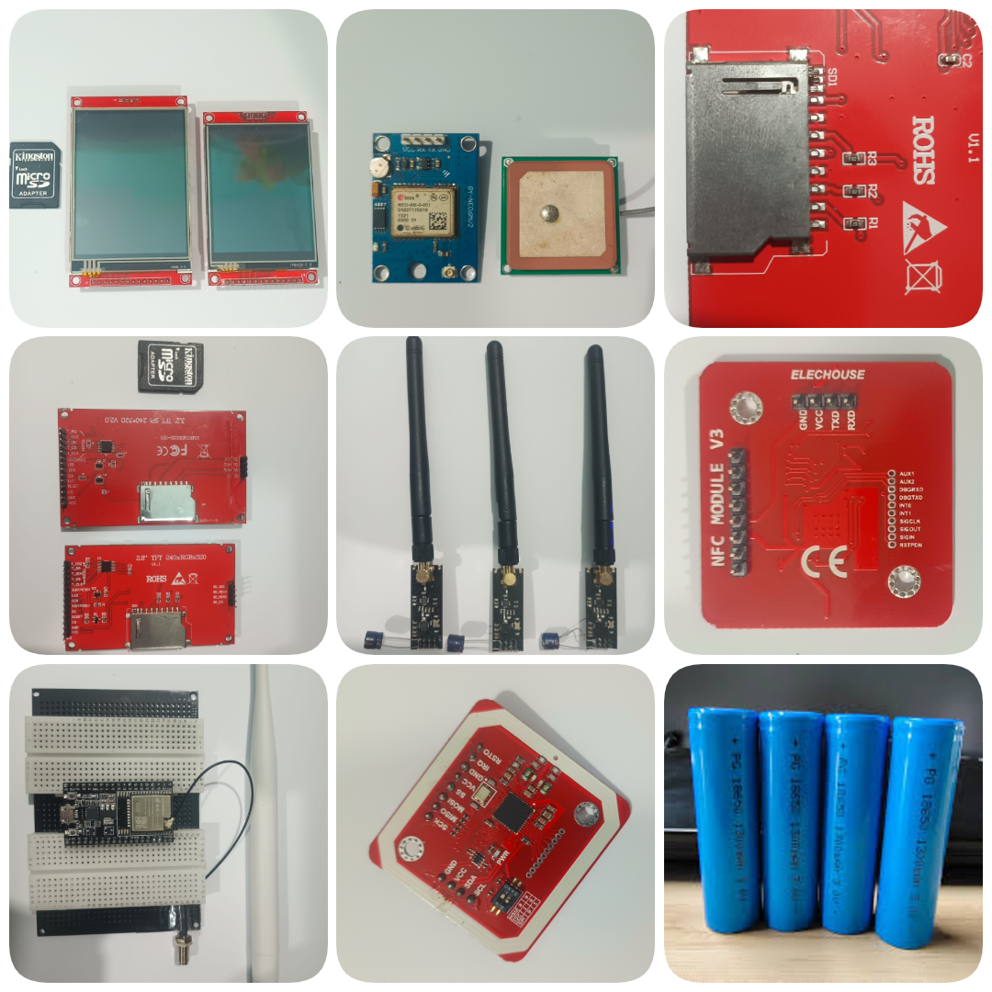
Pin Explanations: -
1. The SPI "Telephone Line" Pins
These three pins are shared by almost everyone. This is where the most conflicts happen.
- MOSI (Master Out Slave In): The Manager speaking. The ESP32 sends commands to the modules.
- MISO (Master In Slave Out): The Employee speaking. The module sends data back to the ESP32. (This is the most common conflict point!)
- SCK / CLK (Serial Clock): The Metronome. It keeps everyone in sync so they know exactly when to send a bit of data. If this signal is noisy, the data becomes "gibberish."
2. The "Control" Pins
These pins are usually unique to each module.
- CS / SS (Chip Select / Slave Select): The "Name Tag." When the ESP32 wants to talk to the SD card, it pulls the SD card's CS pin to Ground. It’s like saying, "Hey SD Card, I'm talking to YOU now—everyone else, shut up."
- DC / RS (Data/Command): The "Context" switch. Mostly used for screens. It tells the screen: "The next thing I send is a command (like 'turn off')" or "The next thing is data (like 'color this pixel red')."
- RES / RST (Reset): The "Panic Button." It forces the module to start over from scratch.
- IRQ (Interrupt Request): The "Interrupting Cow." If a module has new data (like a captured Wi-Fi packet), it taps the ESP32 on the shoulder via this pin so the ESP32 doesn't have to keep checking "Do you have data yet?" every millisecond.

3. Why do they cause conflicts?
In a perfect world, when the CS (Chip Select) pin for the SD card is "High" (OFF), the SD card should be totally silent. However, in the real world of cheap hardware, conflicts happen for three reasons:
A. The "Greedy Employee" (MISO Conflict)
Many cheap SD card modules are "greedy." Even when the Manager (ESP32) says "I'm talking to the NRF24 now," the SD card doesn't let go of the MISO line. It keeps its hand on the phone, creating electrical noise. When the NRF24 tries to talk, the signals collide.
- Your Fix: You used a DPDT switch to physically cut the power. You didn't just tell the employee to be quiet; you sent them home for the day.
B. Signal "Noise" (SCK Conflict)
Because the SCK (Clock) pin is pulsing millions of times per second, the wires act like tiny antennas. If you have too many modules connected to the same clock line on a breadboard, the signal gets "blurry." The modules can't tell the difference between a "1" and a "0."
C. Pin "Strapping" (The Boot Loop)
The ESP32 checks certain pins (like GPIO 0, 2, 12) the very millisecond it turns on to decide how to boot.
- If your RFID or SD card is "pulling" one of these pins up or down at the wrong moment, the ESP32 might think you are trying to "re-program" it, and it will refuse to start the screen.
Switches We used and why we used them and all the components used:-
Also how the switches work-
1. The Components List (The "Ghost Wire" BOM)
To build this for under 30,000 PKR, we sourced specific components that offer the best "price-to-performance" ratio found in local markets like Digilog.
- ESP32-WROOM with Ili9341 display (CYD): The "Brain" with an integrated 2.8" touch screen.
- NRF24L01+ PA/LNA: The long-range 2.4GHz radio for sniffing/hijacking.
C1101 Module.
- RC522 RFID Module (I2C Mod): For 13.56MHz tag cloning and sniffing.
- GPS Neo-6M: For logging coordinates during wardriving.
- V8 Battery Shield: The power plant that regulates voltage for all modules.
- 2x 18650 Li-ion Cells (Purple): Provide the 4000mAh reservoir for 11-hour sessions.
- 12mm Tactile Button: Our dedicated hardware reset trigger.
- 6-Pin DPDT Slide Switch: The "Bus Isolator" for the SD card.

2. The Switches: How They Work & Why We Used Them
A. The 6-Pin DPDT Switch (The SD Card "Kill Switch")
How it works:
DPDT stands for Double-Pole, Double-Throw.
- Double-Pole: It has two separate "lanes" (like a two-lane highway).
- Double-Throw: It can connect the middle pins to either the top pins or the bottom pins.
- In our project: We used it as a Dual-Line Break. One lane controls the Positive (VCC) and the other lane controls the Negative (GND).
Why we used it:
This is the "Secret Sauce" of your build. Most people only switch the Positive wire. However, through the MISO/MOSI data lines, an SD card can sometimes stay "parasitically" powered even if the VCC is cut. By cutting both VCC and GND, we ensure the SD card is electronically "dead." This clears the SPI bus so the NRF24 can operate at 100% speed without interference.
B. The Tactile Push Button (The "Launcher" Reset)
How it works:
This is a Normally Open (NO) momentary switch. The circuit is "broken" by default. When you push the button, a metal disc inside snaps down and connects the two sides.
Why we used it:
Since you are using the bmorcelli launcher, you need a way to "exit" a firmware (like Marauder) and go back to the menu.
- We wired this to the EN (Enable) pin.
- When you click it, it "drains" the power from the ESP32 chip for a millisecond (pulls it to Ground), forcing the CPU to restart.
- This is much faster and safer than flicking the main power switch on the battery shield, which could cause SD card data corruption.
C. The Main Slide Switch (On the V8 Shield)
How it works:
This is a high-current SPST (Single-Pole, Single-Throw) switch built into your battery shield.
Why we used it:
It acts as the Master Isolation. When this is off, the Li-ion batteries are physically disconnected from the 5V/3.3V regulators. This prevents "Vampire Drain," ensuring your batteries don't die while the device is in your bag.

3. Quick Summary of Module Conflicts
Component | Conflict | Solution
SD Card | Jams the MISO line for NRF24 | DPDT Switch physically removes it from the bus.
RFID | Fights for SPI timing | Moved to I2C Bus (GPIO 22/27) to give it a private lane.
GPS | Blocks USB Programming | Moved to GPIO 16/17 (Serial2) to keep the main Serial port free.
NRF24 | Causes "Brown-out" resets | 18650 Battery Shield provides high-current stability.
Wirings (In depth):-
1. The RF Module Matrix (CC1101 & NRF24L01)
To run both simultaneously, they share the MOSI, MISO, and SCK (the "Data Highway") but use separate CS (Chip Select) and CE/GDO pins to tell the ESP32 which radio is talking.
Module Pin | ESP32 GPIO (CYD) | Connection Location
Common SCK | GPIO 18 | P3 Header
Common MOSI | GPIO 23 | P3 Header
Common MISO | GPIO 19 | P3 Header
NRF24 CE | GPIO 22 | CN1 (I2C) - SCL Pin
NRF24 CSN | GPIO 21 | Backlight Control*
CC1101 CSN | GPIO 27 | CN1 (I2C) - SDA Pin
CC1101 GDO0 | GPIO 35 | P3 Header / Labeled LOU
CSN Conflict: On the CYD, GPIO 21 controls the backlight. If your NRF24 is active, the screen might flicker.

2. Peripheral Wiring (RFID, GPS, IR)
RFID (PN532/RC522) - I2C Mode
Since you've opted for I2C to save SPI pins:
- SDA: GPIO 27 (Shared with CC1101 CSN via the DPDT switch if needed).
- SCL: GPIO 22 (Shared with NRF CE).
- VCC: 3.3V.
GPS (Neo-6M) - Serial
- TX (GPS): GPIO 16 (RX2).
- RX (GPS): GPIO 17 (TX2).
- VCC: 5V (from Battery Shield).
IR Modules (KY-005 / TSOP)
- IR TX: GPIO 4 (Standard Bruce output).
- IR RX: GPIO 0 (Standard Bruce input).

3. Complete Power & Switch Integration
Following the "Dual-Cut" logic from your schematics:
DPDT Switch (The SD Card Isolation)
- Top Pins: Input 5V & GND from the V8 Shield.
- Middle Pins: VCC & GND to the Micro SD Module.
- Bottom Pins: (Optional) Could be used to cut power to the CC1101 if you notice interference.
The Reset Button
- Pin 1: ESP32 EN Pin.
- Pin 2: Common GND rail.

4. Wiring Table Summary
Component | VCC | GND | Data 1 | Data 2 | Clock/CS
NRF24L01 | 3.3V | GND | MOSI (23) | MISO (19) | SCK (18) / CSN (21)
CC1101 | 3.3V | GND | MOSI (23) | MISO (19) | SCK (18) / CSN (27)
SD Card | 5V* | GND* | MOSI (23) | MISO (19) | SCK (18) / CS (5)
GPS | 5V | GND | TX (16) | RX (17) | —
RFID | 3.3V | GND | SDA (27) | SCL (22) | —
In addition there must be a 100nF and 10uF capacitor pair near the power lines. Do not skip these. Place them as close as possible to the NRF24L01 and CC1101 power pins. Without them, the radio "noise" will crash the ESP32 every time you try to transmit. (solder them to vcc and gnd pins of the nrf and cc1101 if conflicts occur ).

